



**PLAN**

**LOCAL ECONOMIC DEVELOPMENT**

**BERESAN CITY ASSOCIATED TERRITORIAL COMMUNITY**

**"The plan was developed with the support of the Mayor for Economic Growth initiative of the European Commission and examined by World Bank experts who believe that the plan is in line with the principles of the above-mentioned EC Initiative.**

**The content of the document is the property and responsibility of the Berezan City Community Territorial Community. "**

**Ukraine**

**January 2019**

**Preface**

****Dear friends!

In early 2017, the European Union launched a new initiative for local self-government, namely the "Mayors for Economic Growth", which focuses on sustainable economic development.

We suggest to your attention the Plan of local economic development of Berezan city association territorial community, developed within the framework of the EU initiative "Mayors for Economic Growth". This is a new initiative of the European Union aimed at promoting the local authorities of the countries of the Eastern Partnership and, in particular, Ukraine. The focus of this Initiative is to promote sustainable local economic development and support local government in the development and implementation of such development plans. At the same time, the main focus of the Initiative is to promote the development of the private sector, high-quality employment and the welfare of local residents.

The aim of the Plan is to strengthen the competitive position of the Berezan City OTG as a region in general thanks to the support of the most advanced branches of the economy, as the activation of the existing business allows it to compete effectively, attract investments and stimulate the creation of new enterprises and workplaces. As a result of business growth, the volume of production and sales of local products will increase, and, accordingly, tax revenue will increase. The city council will receive a resource for budget investments in infrastructure development, thus becoming a community even more attractive for business and further improving the quality of life of its inhabitants.

In order to prepare the Plan, a working group was formed that analyzed various aspects of business functioning and worked out strategic priorities, the solution of which would significantly improve the state of the economy and create jobs.

In case of successful implementation of the program, we will be able to achieve the strategic goal of community development, which will be the focus of the introduction of better business experience, which will provide new opportunities for investment in partnership and employment growth.

I propose to all members of the community: private entrepreneurs, community organizations and local people to join the implementation of the Local Economic Development Plan - this will enable you to ensure stable employment and increase the well-being of each family.

Mayor Volodymyr Timchenko!

To get a copy of this plan, contact:

Name: Yakhno Keterina Grigoryevna

Position: Manager of the Berezan City Council executive committee

address street: Heroes of Heavenly Hundred, 1, Berezan, Kiev region

phone / fax: (04576) 64707

e-mail: berezan_mr@ukr.net

Website: http://berezan-rada.gov.ua

**Content**

Page

1. Summary 4

2. List of schemes and tables 5

3. List of abbreviations 5

4. Introduction to the Plan 6

5. The process of developing a Local Economic Development Plan 7

6. Local economic analysis 7

6.1. Analysis of the local economic structure 7

6.2. Cross-sectoral cooperation and interaction at the local level 9

6.3. A transparent, corruption-free administration that promotes business development 10

6.4. Access to funding 10

6.5. Land Resources and Infrastructure 10

6.6. Legal and institutional basis 11

6.7. Skilled labor resources, inclusiveness 12

6.8. External positioning and marketing 13

7. SWOT analysis

8. Vision and Goals 14

9. Action Plan 15

10. Scheme of financing 16

11. Indicators and monitoring mechanisms 18

Annex 1: Order for the creation of a Working Group

Annex 2: The composition of the working group

Annex 3: Order for the amend the Working Group on Development of the Plan of local economic development of Berezan city association territorial community

**1. Summary**

The Local Economic Development Plan is designed to participate in the EU's "Mayors for Economic Growth" initiative and aims to ensure the sustainable development of the Berezan City OTG in the medium term. Achievement of the goal will be carried out on the principles of public-private dialogue through the implementation of measures to stimulate economic growth, which promote the activation of the private sector of the economy and increase the level of employment, broad involvement of public organizations in participation in social and cultural processes, as well as increase the welfare and quality of life of citizens.

Berezan city OTG is located on the Left Bank of the Kiev region, in the eastern part of the metropolitan area. The community consists of six settlements, of which five are rural. The community center is a city of regional significance Berezan. This status was acquired by the city in accordance with the Resolution of the Verkhovna Rada of Ukraine dated June 30, 1994 No. 72/94.

Berezan is located at a distance of 75 km from the regional center.

The boundaries of the community border east and south with settlements of the Baryshevsky area, from the west and north - with the settlements of the Zgurovsky district of the Kyiv region.

The area of the community is 171.51 sq.km, which is 0.63% of the territory of the Kiev region.

As of 01.01.2018, the total number of available population of the city is 21,142 people (109,662 men and 11,013 women).

For Berezan City OTG, local economic development is, first of all, the unification of the efforts of the business community, government and civil society in order to improve the quality of life in the city, growth and effective use of the community's economic potential. And PMER is the city's first attempt to approach the planning of economic development as a promising system for the implementation of a number of partner projects.

This PMER is not comprehensive and does not replace existing plans, but defines the joint activities of the municipality, business entities and local business support institutions for the next 2 years. The basis for the development of a plan of measures aimed at local economic development have already been developed by the community program documents: Plan of socio-economic development of Berezan city OTG in 2019, Program of development of small and medium enterprises of the Berezan city combined territorial community for 2019-2020, The program of investment attraction and improvement of the investment climate for 2019-2021 years.

The plan was developed in partnership with representatives of the private sector and civil society. In addition to the members of the working group, the Berezan City NGO "Association of Entrepreneurs Berezan", Charitable Foundation "Berezan Community Foundation", individual entrepreneurs, heads of small and medium-sized enterprises were involved in the development of the PMER.

Based on the results of the SWOT analysis, the main focus of this Plan is on the development of industry, the creation of conditions for agriculture, the use of industrial premises and free land for investment attraction, the development of information and consulting, education services for entrepreneurship and public-private partnership in development and support of SMEs.

The results of work on the analysis of the local economic structure identified the following main objectives of local economic development:

- Creating an effective system of support and business services provision;

- preparation and development of labor resources for small and medium-sized businesses;

- development of public-private partnership in the field of development and support of small and medium-sized businesses.

The main measures of PMER include: conducting training events for small and medium-sized businesses and their employees; providing consulting services to small and medium-sized businesses, in particular through creation and support of the work of the information and consulting portal; Measures to improve the competitiveness of local producers' products and their promotion to foreign markets; providing business assistance in attracting additional funding; creation of a positive image and popularization of entrepreneurial activity; Establishing an effective dialogue between government and business. Financing of the implementation of PMER measures will be carried out at the expense of the city budget, state budget, private equity funds.

**2. List of schemes and tables**

Table 1. Action Plan

Table 2. Scheme of financing

Table 3. Monitoring indicators

Table 4. Area of the Berezan City Territorial Community

Table 5. Demographic situation, labor market

Table 6. An active trading network

Table 7. Assessment of cooperation at the local level

**3. List of abbreviations**

Local government is a local self-government body

ZU - the law of Ukraine

FOP - an individual entrepreneur

PP is a private enterprise

LLC - Limited Liability Company

OTG - a united territorial community

TsNAP - Center for the provision of administrative services

The EU is the European Union

DFRD - State Fund for Regional Development

PMER - Local Economic Development Plan

SMEs - small and medium entrepreneurship

**4. Introduction to the Plan**

This Plan has been developed in accordance with the methodology and coordination of the European Union's "Mayor for Economic Growth" Initiative. In January 2018, the Berezan City Mayor signed the Membership Agreement and made a commitment to implement a series of measures aimed at supporting the private sector, in particular, along with local business and civil society, to develop a Local Economic Development Plan.

The Berezan city combined territorial community is located on the Left Bank of the Kiev region, in the eastern part of the metropolitan area. The community consists of six settlements, of which five are rural. The community center is a city of regional significance Berezan. This status was acquired by the city in accordance with the Resolution of the Verkhovna Rada of Ukraine dated June 30, 1994 No. 72/94. Berezan is located at a distance of 75 km from the regional center.

The boundaries of the community border east and south with settlements of the Baryshevsky area, from the west and north - with the settlements of the Zgurovsky district of the Kyiv region.

The area of the community is 171.51 square meters. km, which is 0.63% of the territory of the Kiev region.

In our understanding, the importance of local economic development is to create conditions for the development of agro-entrepreneurship and to increase the incomes of rural households. Therefore, the creation of favorable local conditions for this direction is the key task of the Berezan City OTG within the framework of the EU's "Mayors for Economic Growth" initiative, which is a process that benefits the entire community, including local authorities, business and citizens. Successful long-term local economic development requires a genuine partnership between local authorities, the city's business community, the agro-industry sector and other important parts of the community, provides a systematic tool for managing change and reaching consensus in the community on a shared vision of a better economic future - the Local Economic Development Plan (further PMER)

The aim of the PMER is to strengthen the Berezan City OTG's competitive position by supporting the most advanced industries (industry, agriculture), as the activation of existing agribusiness allows it to compete effectively, attract investment and stimulate the creation of new enterprises and jobs. As a result of the growth of agro-entrepreneurship, the volume of production and sales of local products will increase, and, accordingly, tax revenues will increase. The city council will receive a resource for budget investments in infrastructure development, thus becoming a community even more attractive for business and further improving the quality of life of its inhabitants.

Prior to joining the EU initiative, local enterprises favored their own plans and development strategies, without taking into account the potential of joint actions with local partners. The new approach to economic development through the methodology of the EU initiative "The Mayors for Economic Growth" opens up new ways and prospects for the development of agrarian business. In the business environment, local partnership is already seen as a real chance to boost economic growth, increase profits, and create new jobs. One of the first steps was the issuance of the Mayor's Decree No. 26 dated February 27, 2018, which established the Working Group on Development of the PMER of the Berezan City OTG and the Decree No. 32 of 22.03.19 on amendments to the Working Group.

The PMER of Berezan City OTG is developed in dialogue and close cooperation with the private sector with the participation of a public organization, it is aimed exclusively at the development of agribusiness, which is new experience for the community. During the development of the PMER, public information was widely disseminated, local information resources were used: the Berezansky community public-political newspaper, the official web site of the Berezan City Council and its executive committee http://berezan-rada.gov.ua. On average, the community site has a monthly view of 5100 users.

In addition, the Berezan Media Center was created on social networks: https://www.youtube.com/channel/UCV-h5nmYC-r21v5b4YB2WSQ/feed, currently 403 signers;

Facebook page Berezan Media Center - https: //uk-ga.facebook.com/people/Berezansky-MediaCenter, 3110 active members;

Facebook page - Berezan. The Berezan City Community Territorial Community - https://www.facebook.com/groups/berezan, currently 6750 active members;

Facebook page - Berezan City Council and its executive committee https://www.facebook.com/berezan.rada, currently 760 active members.

It is planned to prepare a separate decision to approve the PMER and make changes to the budget of the community in terms of financing the measures of the Plan.

**5. The process of developing a Local Economic Development Plan**

The City Mayor's Decree No. 26 of 27.02.2018 established a Working Group on the Development of the Berezan Economic Development Plan (Order No. 32 of 22.03.1932 on amendments to the Working Group). The meeting was held and it was decided to join this initiative, sign the membership agreement and take a number of measures to ensure sustainable economic development. One of such measures is the development, in cooperation with the private sector and public organizations of civil society, of the Berezan City OTG Local Economic Development Plan.

The working group decided to use the Berezan Master Plan, the Plan of Socio-Economic Development of the Berezan Municipal Territorial Community for 2019-2021 and the operational programs of the Berezan City OTG as the basis for the basic basis.

In developing country-wide development programs, the main methodological principles were applied:

- a deep and systematic analysis of the city's economic and social development and the formation of realistic forecasts based on it;

- expert analysis of internal potential and competitive environment;

- formation of a realistic vision of the future and the formulation of real and achievable strategic goals based on socio-economic analysis;

- formation of a plan of action taking into account available resources, their sources, timing of tasks realization, performance criteria and specific performers;

- Harmonization of the basic principles of the programs with all the most important sectors of the community; taking into account public opinion through mechanisms of wide involvement of the public in the planning process;

- development of programs taking into account the existing planning documents of the city, as well as other territorial-administrative units, which includes the community;

- involvement of local experts in the development of documents;

- working out of an effective system of management of development programs, correction, updating and monitoring of implementation.

The method of data collection is to use statistical information, data that is freely available on the Internet, obtained through a survey and based on the evaluation characteristics of the members of the Working Group. The working group has been working on collecting materials for analysis on an ongoing basis. The development process of the PMER was carried out from the bottom to the top, under the direction of the local coordinator. Third-party specialized organizations were not involved in the development of the Plan. The decision-making process was carried out through discussion, sometimes long-term, but in the end there were always compromise ideas that met all the participants in the process. The final decisions were taken by voting by a majority of votes. The stages of PMER development were covered at weekly hardware meetings.

**6. Local economic analysis**

**6.1. Analysis of the local economic structure**

The Berezan city combined territorial community is located on the Left Bank of the Kiev region, in the eastern part of the metropolitan area. The community consists of six settlements, of which five are rural. The community center is a city of regional significance Berezan.

The area of the community is 174.14 square meters. km, which is 0.63% of the territory of the Kiev region (Table 4).

In the general structure of the population of the community, the urban population is 16.6 thousand people, or 78 percent, the rural population is 4.5 thousand people, or 22 percent.

The population of the able-bodied age (15-70 years) is about 63% of the total population, the population of retirement age - more than 20%. The demographic development of the community is negatively affected by the decrease in the birth rate of children in recent years, as well as the growth rate of natural population decline (more than twice in 2018 compared to the previous year) (Table 5).

The problem of rational use of the labor force, its correct division between sectors of activity, the elimination of unemployment, etc. is acute on the territory of the community. Proximity to the capital and the level of remuneration in the oblast center determine the employment of a significant number of able-bodied population in Kyiv, mainly male. Creating new jobs at innovative industrial or agricultural enterprises will help return this able-bodied population to the community.

Due to the advantageous geographical location on the left bank of the Kyiv region, Berezansky city combined territorial community has developed transport infrastructure. Here intersect the automobile and railway lines with the connection of Chernihiv - Kiev - Poltava - Kharkiv. Through the territory of the community is a strategic highway of international importance M-03.

An analysis of the socio-economic situation in 2018 indicates positive trends in the development of major industries (spheres of activity). The results of socio-economic development are characterized by the following indicators:

- the index of industrial production made 106%, the volume of realized products of enterprises - 1265 mln. UAH, which is 8.7% more than in 2017; Bella Center, a branch of LLC branch "Aerok-Berezan" carry out modernization and technical re-equipment of production and expand the assortment of own products;

- The volume of capital investments for the year is 54 million UAH, which is 4.2% more than in 2017 in comparable prices;

- The total volume of foreign direct investment as of 10/01/2018 (aggregate) amounts to USD 46.8 million. The United States, and per capita - 2808 dollars. USA, which is three times more than the average oblast indicator;

- volumes of commissioned housing made 5.5 thousand square meters. m (47 homesteads type), which is 2.4 times more than in 2017;

- 332 unemployed and unemployed persons are employed in vacant and newly created jobs, which is by 40% more than in the previous year; the employment rate of the unemployed was 47.6% (35.2% in the oblast);

- 265 new jobs created;

- The average monthly nominal wage amounted to UAH 1,013, which is 5.5 times the minimum subsistence level per one able-bodied person; there is no arrears of wages;

- The average size of labor pensions increased by 1.5% and amounted to 2267.83 hryvnia.

Small and medium entrepreneurship is an integral part of the economy of the community. Registered 514 legal entities - small and medium business entities, 427 of them are micro enterprises, 17 - small, 15 - medium enterprises. Number of natural persons-entrepreneurs as of 01.01. 2019 was 707, of which 705 FOPs belong to microenterprises, 2 FOPs - to small businesses. There are 24 farms and 12 agricultural producers on the territory of the Berezan City Integrated Territorial Community. The volume of revenues from small and medium enterprises in general to budgets of all levels for 2018 - 95.5 million UAH. The share of taxes and payments from small and medium-sized enterprises in the total amount of revenues in 2018 was 63.7%.

The consumer market in the community is characterized by a sufficient level of commodity saturation, a stable balance of demand and supply. (Table 6).

Consequently, the most important for economic development of the industries with the greatest potential in terms of creating high-quality jobs, generating local incomes and strengthening them through the creation of value chains is the innovative development of industry, the development of agro-entrepreneurship, the orientation of agricultural systems for the cultivation and processing of fruit and vegetable products, the strengthening organizational and economic assistance in the creation and functioning of family-type farms with their further unification m agricultural cooperatives.

**6.2. Cross-sectoral cooperation and interaction at the local level**

Effective communication - listening and listening, information sharing, and sharing key messages are among the key elements in establishing a good dialogue between government, business and the community. In Berezan OTG, intersectoral cooperation is based on the principles of partnership. The main principles governing the municipality when establishing a partnership are the equivalence of interests, the use of resources of power and business for mutual benefit and the joint solution of problems through consultations and agreements. Today one of the priorities of the city council is to overcome mistrust between government and business and the passivity of the public sector.

In Berezan, a system of cooperation and interaction with public organizations representing interests of various spheres of city life, namely: economic, social-cultural, sporting, tourist, ecological, is established. In total in the city registered and operates 42 associations of citizens. The City Council actively cooperates with all organizations, takes part in the events initiated by them. Organizations whose activities are aimed at supporting the most vulnerable sections of the population, financial assistance from the city budget is provided.

The priority direction in cooperation at the local level is the introduction of public-private partnership as a system of city-business relations, which brings together joint resources with the allocation of risks, responsibilities and rewards, for the mutually beneficial cooperation on a long-term basis in the creation or renewal of new and / or the modernization or reconstruction of existing urban facilities that require investment attraction and use or exploitation.

In order to promote the development of the economic sectors, priority directions were also chosen for the development of agriculture, namely in the field of vegetable growing, horticulture, and potato growing. One of the new directions is the development of festival tourism. It should be noted that the local self-government body engages the public in the socio-economic development of the community. City authorities, together with NGOs and the public, discuss community problems and seek ways to resolve them.

The city council has developed a certain database of telephones and e-addresses of business representatives, grouped contact data by type of activity. On the other hand, the launch of donor programs targeted business assistance is regularly monitored. It enables timely and targeted informing business entities of additional forms of financing and support, invite working groups to meet for a detailed study of the needs, conduct an on-line survey. At the same time, the number of businessmen who submitted applications for grants is very small due to lack of knowledge and skills in project management. Recently, the city council held a number of meetings to establish a constructive dialogue between government and business, but a significant number of business representatives still takes these steps with distrust.

Affiliate interaction between enterprises in the agro-industrial complex is not at a high level, therefore relations are carried out only within the limits of agreements on purchase-sale of goods, works, services. Industry entrepreneurs would like to be able to combine resources to improve the logistics and competitiveness. In order to stimulate CBOs, an economic partnership can be implemented through co-financing by the city council of donor programs aimed at supporting and developing business, promoting investment activities. Continue interaction in the legal field, in particular, involving entrepreneurs in participation in working groups and committees of the city council for solving topical issues of the community. Cooperation in the organizational sphere can be accomplished by promoting the creation of cooperatives in the field of production and processing of agricultural products. To this end, it was decided to introduce an explanatory work on the benefits of cooperative movement in social media and the media.

Thus, the degree of influence of the authorities on the development of private business is considered insignificant and, accordingly, there is an urgent need for inter-sectoral cooperation and interaction (Table 7) in the areas of operational response and the solution of topical business development issues; promotion of local products; assistance in attracting additional funds for business development; stimulating the development of priority sectors of the economy; stimulating the establishment of business contacts.

**6.3. A transparent, corruption-free administration that promotes business development.**

In its activity, Berezan City OTG is guided by the following principles: transparency, non-corruptibility, customer orientation (residents, investors, etc.), responses to needs. The sessions of the Berezan City Council are held with the help of the Rada Voice electronic voting system and are open to the public, during the meetings there is a live broadcast on-line. The decisions of the Berezan City Council and the executive committee are published on the website of the city council, and purchases are made through the state-owned electronic system "Prozorro".

Currently, "Electronic Petition" functions in the test mode for the purpose of responding to the petitions of citizens. Involved local information resources: public-political newspaper "Berezanska community", u-tub channel "Berezan Media Center", which detail the activities of the city council. In parallel, the information is placed on individually created pages in social networks.

The development of local legal documents is carried out in accordance with the requirements of the Law of Ukraine "On the Basic Principles of Regulatory Policy in the Field of Economic Activity". The site contains regulatory acts, as well as the decisions of the city council and its executive committee.

The Berezan City Council, the Center for the Provision of Administrative Services to the Executive Committee of the Berezan City Council (CNAA), was established in 2013. The organization of the provision of administrative services at TsNAPis is carried out by the administrators on the basis of the " single window". In 2018, the number of administrators increased to 6 people.

Through the CIAP is provided 188 types of administrative services The reception of the subjects of appeals is carried out six days a week without a break for lunch.

The overhaul of the premises of the TsNAP was carried out in 2017. However, the increase in the number of services provided, the creation of comfortable conditions for service of the subjects of appeals requires the expansion of the square CNPU. In order to bring administrative services in the most remote settlements of the community, there is a need for the acquisition of a mobile CNTA.

The most frequent applications for such services are: registration of a passport of a citizen of Ukraine for traveling abroad, passport of a citizen of Ukraine in the form of an ID-card, photo sticking in the passport of a citizen of Ukraine, registration / removal from registration of the residence of a citizen of Ukraine and a young child, obtaining an extract from the State Land a cadastre, a state registration of a land plot, the receipt of a certificate of 6-ZEM, obtaining an extract about the normative-monetary assessment of the land plot.

Public hearings are held in Berezan city in order to take into account the public opinion in resolving important issues for the community. Conducting public hearings is not an end in itself for Berezan city OTG. For OMCs, the purpose of the hearings is not only to inform citizens, but rather to receive feedback from the community, to awaken the sense of responsibility and involvement of community members in the OTG residents.

**6.4. Access to funding.**

OMI is actively working on attracting public resources, donor programs and private capital to build local economies. The Berezan City Council organizes roundtables, workshops and conferences with the participation of business representatives in order to facilitate the attraction of funds to the private sector of the economy. Financial services in the community are provided by 2 departments of banking institutions. More than 50 thousand UAH have been allocated to the implementation of the SME Development Program of Berezan City OTG, but this is not enough for real support.

The banking system is not involved at all in the development of the local business environment due to the high rates for the use of loans, which does not allow the financing of really significant projects for community development. Consolidation of financial resources from different sources is required to solve problems with financing of perspective branches of local economic development.

The budget of the general fund of the local budget of Berezan City OTG for 2019 is 94500,0 thousand UAH, which is 3620,3 thousand UAH, or 4%, more compared to 2018.

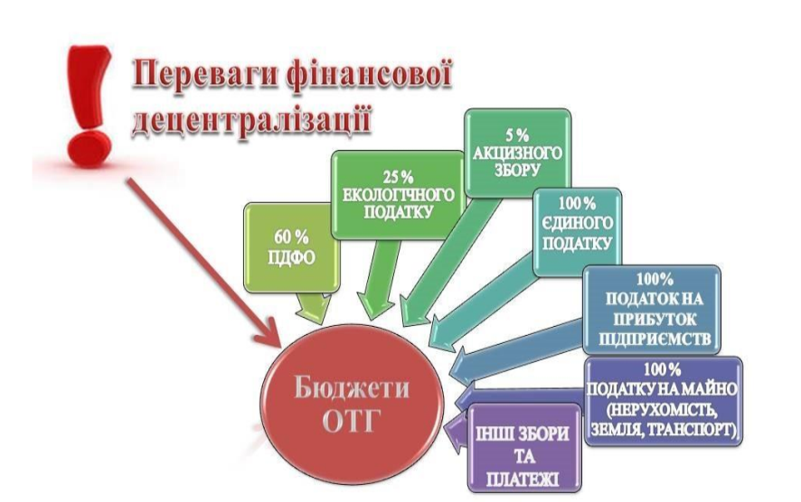

The Berezan City Council, with the assistance of the Charitable Foundation "Berezani Community Foundation", has experience in cooperation with international donor organizations and institutions: Charitable Foundation for Community Development "Left Bank Kyiv Region", ISAR "Unity", International Renaissance Foundation, Charitable Organization "International Charitable Foundation" Updating the country. "

One of the priority tasks of the CSO is to promote the attraction of private investment in the community.

**6.5. Land Resources and Infrastructure.**

The territory of the Berezan City Community is 174.14 square meters. km, including within settlements - 47.12 square meters. km, outside - 127.02 square meters. km Agricultural lands occupy 144.6 square meters. km, including arable land - 126.3 square meters. km, or 72.5 percent in the total area of the community .. On the other hand, regular monitoring of the launch of donor programs targeted business assistance. It enables timely and targeted informing business entities of additional forms of financing and support, invite working groups to meet for a detailed study of the needs, conduct an on-line survey. At the same time, the number of businessmen who submitted applications for grants is very small due to lack of knowledge and skills in project management. Recently, the city council held a number of meetings to establish a constructive dialogue between government and business, but a significant number of business representatives still takes these steps with distrust.

Affiliate interaction between enterprises in the agro-industrial complex is not at a high level, therefore relations are carried out only within the limits of agreements on purchase-sale of goods, works, services. Industry entrepreneurs would like to be able to combine resources to improve the logistics and competitiveness. In order to stimulate CBOs, an economic partnership can be implemented through co-financing by the city council of donor programs aimed at supporting and developing business, promoting investment activities. Continue interaction in the legal field, in particular, involving entrepreneurs in participation in working groups and committees of the city council for solving topical issues of the community. Cooperation in the organizational sphere can be accomplished by promoting the creation of cooperatives in the field of production and processing of agricultural products. To this end, it was decided to introduce an explanatory work on the benefits of cooperative movement in social media and the media.

Thus, the degree of influence of the authorities on the development of private business is considered insignificant, and, accordingly, there is an urgent As a result, the community has significant land resources for productive commodity agricultural production. More than 70 percent of the land outside the settlements is decomposed and leased. Land reserves are also partially leased, but this process is not well-organized and requires inventory. The local authorities signed a memorandum with the structural division of the State Geocodraw in connection with the transfer of agricultural land plots of state ownership to the communal property of the united territorial community.

The Berezan City Council approved the list of free land plots within the settlements, which are planned to be auctioned on land for sale of lease or purchase right (decision of 20.02.2018 № 452-46-VII), the list includes 24 land plots.

Transfer of land lease and sale is carried out on a competitive basis. In 2018, an auction was conducted for the sale of lease rights and leased land parcels of non-agricultural land with an area of ​​20 hectares to implement an investment project for the construction of a sheet glass plant. At the stage of preparation of the following auctions for the sale of the right to lease 4 land plots.

In accordance with the recommendations on the standards of attracting and supporting an investor at the local level, developed by the Office for attracting and supporting investments, UkraineInvest jointly with the Ministry of Economic Development and Trade of Ukraine, updated information on investment proposals: Greenfield - 5 (Berezan Shlyah street, 48), Brownfield - 1 (street Shevchenkiv Shlyah, 157), for lease - 1 (Mikhaylovskaya st., 50, communal property). The information is placed on the official site of the city council and is included in the list of investment proposals of the Kiev region.

Due to the advantageous geographical location on the left bank of the Kyiv region, the Berezansk Unified Territorial Community has transit potential and developed transport infrastructure. It crosses the road and railroad tracks. Through the territory of the community is a strategic highway of international significance M-03 Kiev-Kharkiv-Dovzhanskaya. In the city of Berezan there is the railway platform "Zhovtnevyi" and the railway station "Berezan" of the Southwest railway, which belongs to the 3rd class. The distance to the nearest international airport Borispol is 45 km.

The total length of the roads of the regional significance Baryshivka - Berezan - Yagotin (T-10-18) - 13.8 km, Berezan-Zgurivka (O 101013) - 16 km, local significance - 235 km, including asphalt covering - 223 km .

The road system within the OTG is balanced and capable of ensuring accessibility to all territories and settlements. However, the road surface is unsatisfactory both within and outside settlements. The network of highways requires major repairs, and in some cases a complete replacement of the road surface. For a strategic solution to the issue of heavy vehicle traffic through the city of Berezan there is an urgent need for the construction of a bypass road, which is a significant investment (over 170 million UAH), which the local budget of the community does not have.

The engineering infrastructure of the OTG is advanced, but requires modernization, technical re-equipment, overhaul due to wear and tear of networks and equipment. In order to improve the infrastructure, local budget and higher-budget budgets and own funds of enterprises by co-financing are attracted. The priority of the implementation of such projects is discussed with the public.

Through the CIAP is provided 188 types of administrative services The reception of the subjects of appeals is carried out six days a week without a break for lunch.

The overhaul of the premises of the TsNAP was carried out in 2017. However, the increase in the number of services provided, the creation of comfortable conditions for service of the subjects of appeals requires the expansion of the square CNPU. In order to bring administrative services in the most remote settlements of the community, there is a need for the acquisition of a mobile CNTA.

The most frequent applications for such services are: registration of a passport of a citizen of Ukraine for traveling abroad, passport of a citizen of Ukraine in the form of an ID-card, photo sticking in the passport of a citizen of Ukraine, registration / removal from registration of the residence of a citizen of Ukraine and a young child, obtaining an extract from the State Land a cadastre, a state registration of a land plot, the receipt of a certificate of 6-ZEM, obtaining an extract about the normative-monetary assessment of the land plot.

Public hearings are held in Berezan city in order to take into account the public opinion in resolving important issues for the community. Conducting public hearings is not an end in itself for Berezan city OTG. For OMCs, the purpose of the hearings is not only to inform citizens, but rather to receive feedback from the community, to awaken the sense of responsibility and involvement of community members in the OTG residents.

**6.6. Legal and institutional basis.**

The Berezan City Unified Territorial Community was formed on October 9, 2018, in accordance with the Law of Ukraine "On Voluntary Association of Territorial Communities" by voluntarily joining the territorial community of the city of the regional significance of Berezan territorial communities of Sadovye, Nedra, Lehnivka, Yareshky, Pylypche of Baryshivskyi district of Kyiv the area (the decision of Berezan city council dated 09.10.2019 №№ 578-56-VI, 579-56-VII, 580-56-VII, 581-56-VII, 582-56-VII).

The community operates on the principles of transparency, openness and transparency. The structure of the city council meets the requirements of staffing, infrastructure and financial capacity for full implementation of the powers determined by law at the appropriate level of administrative-territorial units. Distributed and regulated powers of the city council (consisting of 25 deputies) and subordinate executive bodies: the executive committee (24 members) and 14 structural subdivisions. Administrative, permissive and social services are provided through the CNAP. The services are standardized, precise requirements for their quality are developed, criteria for evaluation, indicators of the success of their implementation and procedures for their provision are established.

Modern market conditions and the stabilization of the economy require a revision of the conditions of management in the community. The authorities deviate from direct influence on economic entities and act indirectly through the creation of certain economic and administrative conditions, the totality of which is a sign of the economic climate. Such attributes include: tax regime, the degree of commodity market demonopolization, the state of the real estate market, regulation of urban development, the state and mobility of labor resources, the availability of business information and financial resources.

According to the current legislation, the city council is competent to determine the list and size of local taxes and fees, as well as to set certain other taxes and duties - rates of a single tax, land tax, real estate tax, rent, etc. The establishment of rates of income tax, value added tax, personal income tax, the rate of a single social contribution, the amount of excise duty falls within the competence of higher authorities.

Draft decisions on tax rates are announced in advance, as a rule, a month before their approval. This enables business representatives to participate in their public discussion and influence their adoption. During the development of PMER and interviews with business entities, it was established that the conditions of economic activity, despite some positive changes in recent times, are not yet attractive and there are many obstacles to effective management, including various administrative constraints, a cumbersome system accounting and reporting, and a high level of general tax press.

Complicated, according to entrepreneurs, is the procedure for obtaining a building permit. In addition to a large number of documents, this process requires agreement with a number of government agencies of different departments, which requires additional time. For start-ups, the inherent obstacles are the organizational and legal difficulties of starting a business, especially at the stage of transition from registration to the start of activity and inaccessibility of credit resources for starting, doing business or restoring it.

A significant part of these problems is common to Ukraine and can only be solved at the state level. This means that the active role of the city authorities in lobbying the necessary changes in the legal field is required. At the same time, certain improvements can also be achieved at the local level, in particular, through the introduction of online filing with the CNPP and the introduction of an electronic document flow system among structural subdivisions.

In addition, one of the reasons for the low competitiveness of enterprises in the city remains an imperfect level of management. Therefore, it is necessary to promote the updating of management personnel, support programs for re-training of industrial enterprises managers, training in methods of strategic planning, marketing, substantiation of investment projects.

**6.7. Skilled labor resources, inclusiveness.**

The problem of the community is acutely rational use of the workforce, its correct division between sectors of activity. Proximity to the capital and the level of remuneration in the oblast center determine the employment of a significant number of able-bodied population in Kyiv, mainly male. Creating new jobs at innovative industrial or agricultural enterprises will help return this able-bodied population to the community.

The analysis of the employment status of the community shows that 58 percent of the unemployed are women, and the proportion of young people under 35 years among the unemployed is 36 percent. The main problems are:

- inconsistency of the professional qualification level of the labor force with the needs of the economy and the labor market;

- lack of proper motivation for employees to legal productive employment, mainly due to poor quality of workplace conditions and wages.

Another problem is the significant aging of the population, since almost half of the residents are retired, both by age and by age. The share of pensioners is increasing, while the share of the able-bodied population is decreasing.

The average size of labor pensions for 2018 increased by 1.5% and amounted to 2267.83 hryvnia.

Professional guidance services were used by 2457 unemployed and employed citizens, including 1,310 students of comprehensive schools of the city, which provided only 4172 professional information, professional counseling and professional disqualification services for the past year. 265 new jobs created.

Due to a number of Berezan City Employment Programs and Programs approved by the City Council, a set of approaches to employment, retraining, etc. has been developed. For two years, low unemployment is supported. At the same time, these programs do not apply to members of the private peasant economy, which are considered to be busy, but in the transition to the standards of the World Trade Organization remain unemployed. Therefore, the issue of their training, against the backdrop of rural population, is becoming more relevant. The need for economics in the staff is met by local higher education institutions, which train specialists relevant to the local labor market professions. The expected need for personnel is based, first of all, on the trends in the growth of consumption of agricultural products, therefore, there will be a need for specialists with higher education in the field of agricultural disciplines. Managers, marketers will be needed in connection with the introduction of the free trade area and the simplification of access to foreign markets in the processing industry.

**6.8. External positioning and marketing**

The purpose of achieving a proper level of awareness about Berezan City OTG is to search for new consumer markets for the goods and services produced here, to attract entrepreneurs and investors to the community as a place for starting or moving a business, opening or moving the production facilities, and maintaining and enhancing human capital Berezanka community as its most valuable resource.

In today's world, competition is a permanent attribute of the global environment where communities operate and develop. Due to the intensification and intensification of competition between individual communities, the design of the community brand and the development and implementation of a strategy for its promotion in the epicenter of the global information space becomes relevant. Today, the image of the goods, services in many respects depend on the brand of the territory, from the positioning of the community. From an economic point of view, it is the formation of a clear image of the community as a powerful tool for attracting a large flow of investors and partners. The community becomes a commodity in the territory of the market.

The active presence of the community in the information field, in particular on the Internet, is a prerequisite for its positioning and marketing at the regional, national and international levels. To do this, local governments promote territorial marketing, brand building, community investment passport.

Local entrepreneurs estimate the Berezan community as a place of doing business and investing mostly positively, indicating its favorable geographical location, proximity to the consumer market and good logistics.

In order to increase investment attractiveness and accelerate the community's economic development, the Berezan City Council is actively working on the implementation of community promotion policies. Representatives of the OMC systematically participate in various forums and conferences in order to promote the community and search for potential partners (Kyiv Smart city forum, International Summit, etc.). Also, the Berezan City Council is a member of the Voluntary Association of Local Self-Government Bodies - Association "Energy Efficient Cities of Ukraine" and the European Initiative "Covenant of Mayors".

**7. SWOT analysis**

The SWOT analysis of the Berezan Unified Territorial Community was conducted on the basis of research on the socio-economic status of settlements belonging to the community. On the basis of SWOT-analysis, the identification of problems and the selection of priority areas of community development are carried out.

|  |  |
| --- | --- |
| **Strengths** | **Weaknesses** |
| 1. Favorable geographical location of the united community in the center of the Left Bank of Kyiv region at the intersection of road and rail ways  2. Transit potential and developed transport infrastructure  3. Favorable conditions for agriculture  4. Skilled labor resources  5. Availability of engineering infrastructure, including supply of electricity for industrial consumption  6. Existence of unused industrial premises and free land plots for attraction of investments  7. Developed social sphere  8. Presence of objects of service provision  9. Availability of official channels for informing the population | 1. Differentiation of the quality of life of the inhabitants of the community center and the old-city districts  2. Depleted infrastructure of water supply and drainage, power transmission lines  3. Deterioration of the transport and operational condition of highways of local importance due to increased traffic flows of heavy transport, the absence of a bypass road  4. Outflow of personnel to Kiev due to poor quality of workplaces by conditions and payment, especially for young people  5. Negative demographic indicators  6. Outdated urban planning documentation  7. Low energy efficiency of buildings in the social sphere and housing stock  8. Underdevelopment of the system of leisure activities of the population  9. Inappropriate use of land resources in the Old Ostins districts |
| **Opportunity** | **Threats** |
| 1. Utilization of unoccupied municipal property objects  2. Organize the use of land resources, inventory of land  3. Promotion of energy efficiency and attention to environmental safety  3. Introduction of new approaches in spatial development of the community  4. Preparation and constant updating of investment proposals in accordance with the standards of attraction and support of investors at the local level.  5. Involvement of international technical assistance, donor funds, grants for community development  6. Improving the efficiency of using budget funds by optimizing the network of educational institutions  7. Improving the safety of citizens  8. Provision of social services of citizens who are not capable of self-service in connection with illness, disability | 1. Political and socio-economic instability as a result of election campaigns  2. Aggravation of a military conflict in the east of the country  3. Increased value of all types of resources  4. The presence of the shadow economy  5.Deterioration of climatic conditions due to global warming, which can lead to drought  6. Natural and man-made disasters  7. Imperfection and instability of tax legislation  8. Disappointment of citizens about the positive results of implementation of the initiated sectoral reforms  9. Inconsistency of the professional qualification level of personnel potential with the needs of the economy and the labor market |

Based on the results of the analytical and descriptive part of the SWOT analysis, OTG has chosen a dynamic (competitive) strategy that envisages the formation of competitive advantages of the community by minimizing the impact on the development of the community and its weaknesses through the opportunities that are now emerging in our country and in the world. At the same time, the community should make the most of its strengths.

**8. Vision and Goals**

**Strategic Vision:**

Berezan 2020 is an active, competitive, financially independent, investment-attractive with modern logistics centers and at the same time environmentally friendly community, a territory of harmonious combination of industrial development based on high technology and agriculture.

A community of economically active people, entrepreneurs and entrepreneurs, where it is easy to open and run their own business.

**Main goals:**

1. Development of agro-entrepreneurship:

- conducting a survey of small agricultural producers in order to monitor problematic issues and find ways to solve them;

- popularization of the cooperative movement among small agricultural commodity producers;

- creation of a canning shop for the processing of fruit and vegetable products.

2. Increasing the level of investment attractiveness of the community:

- creation of the information portal of the Berezan City HTE in the field of investment activity;

- Territorial marketing, brand creation, community investment certificate.

3. Development of the public environment:

- implementation of parisipative methods of community management;

- Provision of timely information to the public on the essence and priorities of community development, coverage of the activities of local authorities in the mass media.

**9. Action Plan**

**Table 1. Action Plan**

|  |  |  |  |  |  |  |  |
| --- | --- | --- | --- | --- | --- | --- | --- |
| ***Thematic block*** | ***The main goals*** | ***Project activities*** | ***Duration (start - end)*** | ***Affiliates*** | ***Planned costs(thousand UAH / Euro)*** | ***Results*** | ***Indicators for monitoring*** |
| Cross-sectoral cooperation and interaction at the local level.  Land Resources and Infrastructure | 1. Development of agro-entrepreneurship | 1.1. A survey of small agricultural producers to monitor problematic issues and find ways to address them. | 2019-2020 | City Council, small and medium business | 100,0/  3300 EUR | Conducting workshops with the involvement of farms | At least 80% of agricultural producers |
| 1.2. Popularization of the cooperative movement among small agricultural commodity producers | 2019-2020 | City Council, small and medium business | 120,0/  4000 EUR | Consolidation of resources of agricultural producers in the direction of development | The number of cooperatives created |
| 1.3. Creation of a canning shop for the processing of fruit and vegetable products | 2019-2020 | City Council, small and medium business | 10000,0/  350000 EUR | Level of readiness for commissioning | Creation of modern production infrastructure |
| External positioning and marketing | 2. Increasing the level of investment attractiveness of the community | .1. Creation of an informational portal of Berezan city HTE in the field of investment activity | 2019-2020 | ЄвропоюCity Council, Regional Development Agency, U-LEAD with Europe | 400,0/  13300 EUR | Involving potential investors,  improving the image of the city on the national and international levels | More than 500 visitors per month of information portal of Berezan city OTG |
| .2. Territorial marketing, brand building, community investment investment passport | 2019-2020 | City Council, representatives of public and private sectors | 500,0/  16600 EUR | Recognition and community identification | Increase of attracted investments into the community by 10% |
| A transparent, corruption-free administration that promotes business development | 3. Development of the public environment | 3.1. Introduction of parisipative methods of community management | 2019-2020 | City council, public organizations, business repress tatives | 470,0/  15600 EUR | Involvement of the public in solving community problems | E-petitions, E-consultations, Budget participation |
| 3.2. Providing timely information to the public on the essence and priorities of community development, coverage of local authorities in the media | 2019-2020 | City Council, public organizations, business representatives, U-LEAD with Europe | 260,0/  8600 EUR | Development of communication technologies for increasing users | Number of active members |

**10. Scheme of financing**

**2.** **Table Scheme of financing**

|  |  |  |  |  |  |  |  |
| --- | --- | --- | --- | --- | --- | --- | --- |
| **Project activities** | **Planned costs**  **thousand UAH /**  **euro** | **Джерела фінансування, тис.грн /євро** | | | | **Lack of funding** | **Notes** |
| **Local budget**  **thousand UAH /**  **euro** | **Top-level budgets**  **thousand UAH /**  **euro** | **Private sector,**  **thousand UAH /**  **euro** | **Donors**  **thousand UAH /**  **euro** |
| 1.1. A survey of small agricultural producers to monitor problematic issues and find ways to address them | 10,0/  330 EUR | 5,0/  160 EUR | - | 5,0/  160 EUR | - | - | - |
| 1.2. Popularization of the cooperative movement among small agricultural commodity producers | 90,0/  3000 EUR | 45,0/  1500 EUR | - | 45,0/  1500 EUR | - | - | - |
| 1.3. Creation of a canning shop for the processing of fruit and vegetable products | 10000,0/  350000 EUR | - | - | 3000,0/  100000 EUR | 7000,0/  233000 EUR | - | - |
| 2.1. Creation of an informational portal of Berezan city HTE in the field of investment activity | 400,0/  13300 EUR | 200,0/  6600 EUR | - | - | 200,0/  6600 EUR | - | - |
| 2.2. Territorial marketing, brand creation, community investment investment passport | 500,0/  16600 EUR | 250,0/  8300 EUR | - | - | 250,0/  8300 EUR | - | - |
| 3.1. Introduction of parisipative methods of community management | 470,0/  15600 EUR | - | - | - | 470,0/  15600 EUR | - | - |
| 3.2. Providing timely information to the public on the essence and priorities of community development, coverage of local authorities in the media | 530,0/  17600 EUR | 530,0/  17600 EUR | - | - | - | - | - |

**11. Indicators and monitoring mechanisms**

**Table 3. Monitoring indicators**

|  |  |  |  |  |  |
| --- | --- | --- | --- | --- | --- |
| ***Actions / Project Ideas*** | ***Duration (start of action dd.mm.rrrr - end of dd.mm.yyyy)*** | ***Очікувані результати*** | | | |
| ***from the 1st to the 6th month*** | ***from the 7th to the 12th month*** | ***from the 13th to the 18th month*** | ***from the 19th to the 24th month*** |
| 1.1. A survey of small agricultural producers to monitor problematic issues and find ways to address them | 01.04.2019-01.07.2019 | Establish a working group and define a plan of action.  2. Conduct public hearings on the results of work of the working group.  3. Definition of problem issues | - | - | - |
| 1.2. Popularization of the cooperative movement among small agricultural commodity producers | 01.03.2019 – 01.03.2020 | Create a working group and define a plan of action | Selection and placement of information in the media of the community | Meetings with agricultural producers on the creation of cooperatives | - |
| 1.3. Creation of a canning shop for the processing of fruit and vegetable products | 01.06.2019 – 01.12.2020 | Trainings on the implementation of the U-LEAD Program with Europe have been completed. | . 1. Establish a working group and define a plan of action  2. Development of a project on the creation of a canning shop for the processing of fruit and vegetable products. | Search for donors to be involved in the project | . Putting into operation the canning shop.  Creating jobs. |
| 2.1. Creation of an informational portal of Berezan city HTE in the field of investment activity | 01.03.2019 – 01.12.2019 | Modernization of the community website as a platform for creating an information portal | An information portal Berezan city OTG was created | - | - |
| 2.2. Territorial marketing, brand creation, community investment investment passport | 01.05.2019 – 01.12.2019 | 1. Creating a Brand Advisory Group  2. Development of an investment passport of the community | Creation of the image product of the Burness city OTG community | - | - |
| 3.1. Implementation of participatory methods of community management | 01.05.2019 – 01.12.2020 | Implementation of E-petitions, E-consultations | 1. Implementation of E-petitions, E-consultations  2. Conduct of the tender of proposals | Implementation of the participation budget | Mastering the budget of the participation |
| 3.2. Providing timely information to the public on the essence and priorities of community development, coverage of local authorities in the media | 01.07.2019 – 01.12.2020 | - | Creation of software for implementation of information portal of Berezan city OTG | Extending the practice of using the information portal in the community | In-time informed community |

**Table 4. Area of the Berezan City Territorial Community**

|  |  |  |  |
| --- | --- | --- | --- |
| **№** | **The name of the settlement** | **Total area, sq. M. km** | **Area within the settlement, sq. M. km** |
| 1. | City Berezan | 32,92 | 32,92 |
| 2. | Sadove village | 39,16 | 2,45 |
| 3. | Nedra village | 32,78 | 3,11 |
| 4. | Lekhnivka village | 32,23 | 3,71 |
| 5. | Yareshky village | 17,99 | 2,52 |
| 6. | Pelipche village | 19,06 | 2,41 |
|  | **Total** | **174,14** | **47,12** |

**5. Demographic situation, labor market**

|  |  |  |  |  |  |  |  |  |
| --- | --- | --- | --- | --- | --- | --- | --- | --- |
| **№** | **Indexes** | **Total** | **Berezan** | **Sadove** | **Nedra** | **Lekhnivka** | **Yareshky** | **Pelipche** |
| 1 | The number of existing population as of January 1, 2018, persons | 21142 | 16585 | 1337 | 1069 | 1172 | 625 | 354 |
| 2 | Number | 21975 | 16735 | 1559 | 1201 | 1323 | 751 | 406 |
| 3 | Number of men, persons | 10962 | 8478 | 731 | 566 | 639 | 363 | 185 |
| 4 | Number of women, persons | 11013 | 8257 | 828 | 635 | 684 | 388 | 221 |
| 5 | Number of people younger than the able-bodied age, persons | 3688 | 2861 | 272 | 171 | 158 | 153 | 73 |
| 6 | Number of people of working age, persons | 13851 | 10616 | 953 | 794 | 830 | 429 | 229 |
| 7 | Number of population older than the able-bodied age, persons | 4436 | 3258 | 334 | 236 | 335 | 169 | 104 |
| 8 | Number of persons born in the reporting year, thsd. Persons | 254 | 210 | 13 | 6 | 13 | 8 | 4 |
| 9 | Number of deceased persons in the reporting year, thousand persons | 334 | 240 | 24 | 25 | 24 | 10 | 11 |
| 10 | Natural increase (decrease), persons | -80 | -30 | -11 | -19 | -11 | -2 | -7 |
| 11 | Migration increase (decrease), persons | +17 | +3 | 12 | 0 | 12 | -3 | -7 |
| 12 | The number of registered unemployed persons | 253 | 231 | 9 | 4 | 8 | 1 | 0 |
| 13 | Registered unemployment rate,% | 2,6 |  |  |  |  |  |  |
| 14 | %Employment rate of registered unemployed,% | 50,2 | 52,3 | 44,4 | 50 | 100 | 100 | 0 |

**Table 6. An active trading network**

|  |  |  |  |  |  |  |  |  |
| --- | --- | --- | --- | --- | --- | --- | --- | --- |
| **№ п/п** | **Name** | **Total** | **Berezan** | **Sadove** | **Nedra** | **Lekhnivka** | **Yareshky** | **Pilipche** |
| 1. | Objects of network trade | 7 | 7 | - | - | - | - | - |
| 2. | Establishments | 135 | 119 | 1 | 3 | 7 | 4 | 1 |
| 3. | Wholesale companies | 5 | 5 | - | - | - | - | - |
| 4. | Restaurant service establishments | 26 | 22 | 2 | - | - | 1 | 1 |
| 5. | Markets for the sale of food and non-food products | 2 | 2 | - | - | - | - | - |
| 6. | Retail facilities | 33 | 28 | 4 | - | - | 1 | - |
| 7. | Number of business entities whose activities are related to the provision of household services | 71 | 71 | - | - | - | - | - |

**Table 7. Assessment of cooperation at the local level**

|  |  |  |  |
| --- | --- | --- | --- |
| Name and / or function (field where applicable / topic is relevant) | Institutions / individuals involved | Achievement | Score: useful or not useful |
| Solving topical business development issues | Association of Entrepreneurs under the Executive Committee of the City Council, City Council | On a regular basis | Business decisions are made taking into account business proposals.  Continue to work. |
| Popularization of local products | Business entities from small and medium-sized businesses, city council | On a regular basis | To continue holding the fair of products of local producers during state and local festive events.  To introduce the holiday event is strictly aimed at supporting the local commodity producer. |
| Facilitate the attraction of additional funds for business development | City Council | On a regular basis | Continue informing the business about the terms of participation in grant progra Facilitate the attraction of investment funds for the implementation of business projects |
| Stimulating the development of small and medium businesses | Public organization, small and medium business entities, private peasant economy, Berezan City Employment Center, City Council | At the planning stage | Facilitating educational and educational programs for business in the field of finance, law, project management |
| Stimulating the establishment of business contacts | City council, agricultural societies, farms | At the planning stage | Facilitate partnership building to combine resources to enhance competitiveness |

**Annex 1. Decree on the creation of a working group**

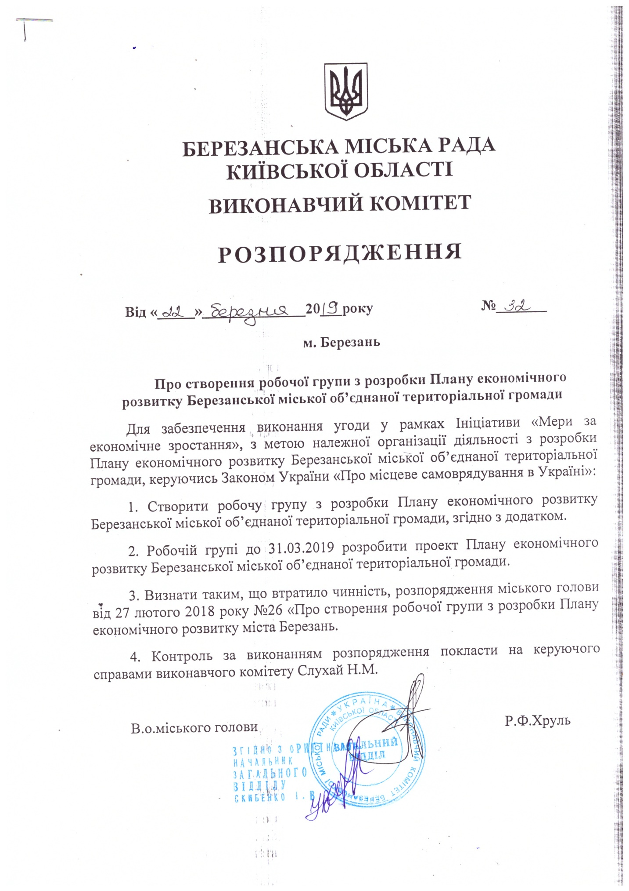

**Annex 2. The composition of the working group**

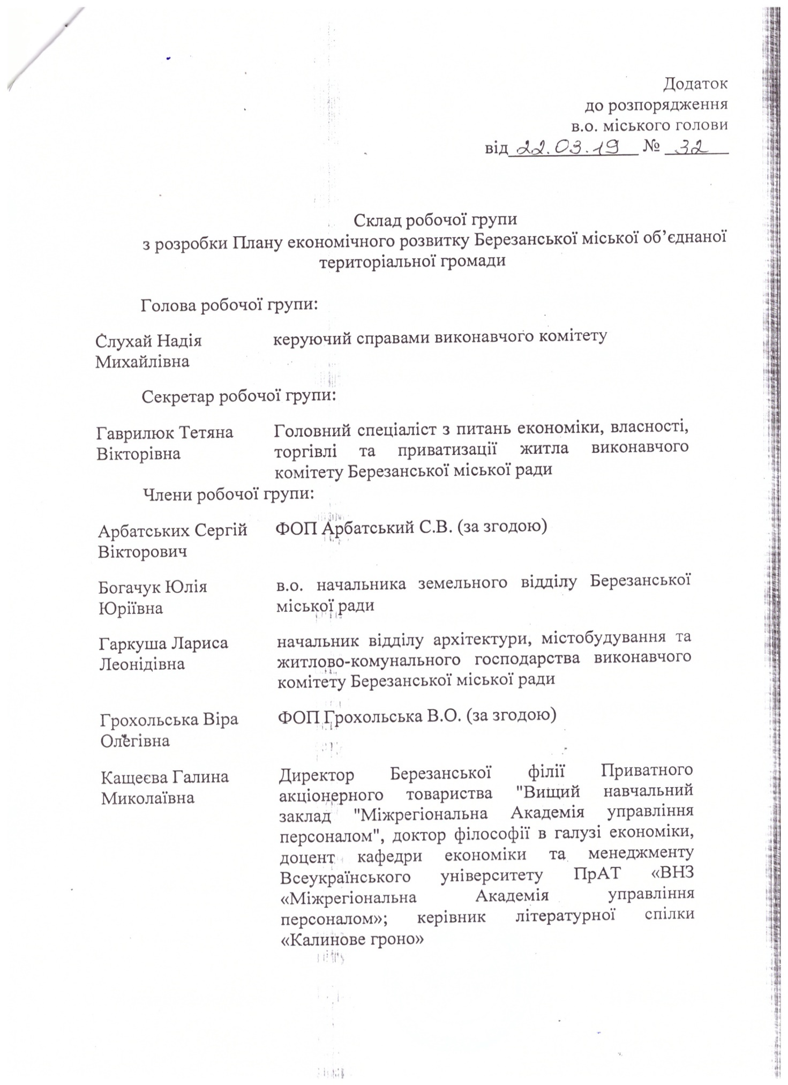

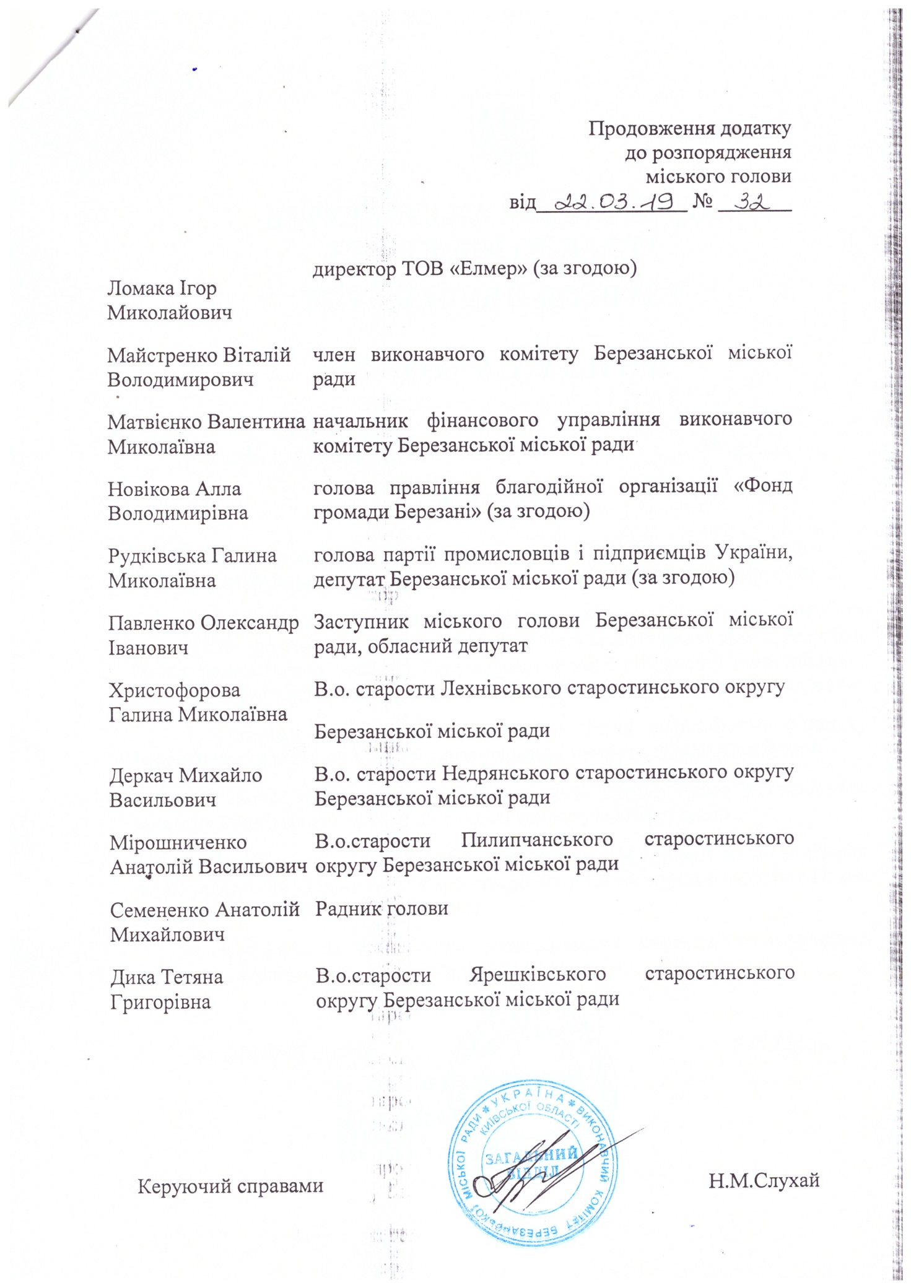

**Annex 3: Order for the amend the Working Group on Development of the Plan of local economic development of Berezan city association territorial community**



